There are different between the SNOMED CT relationships file at 2015.07version, one extra record exist at the output from RF2-RF1 conversion tool:

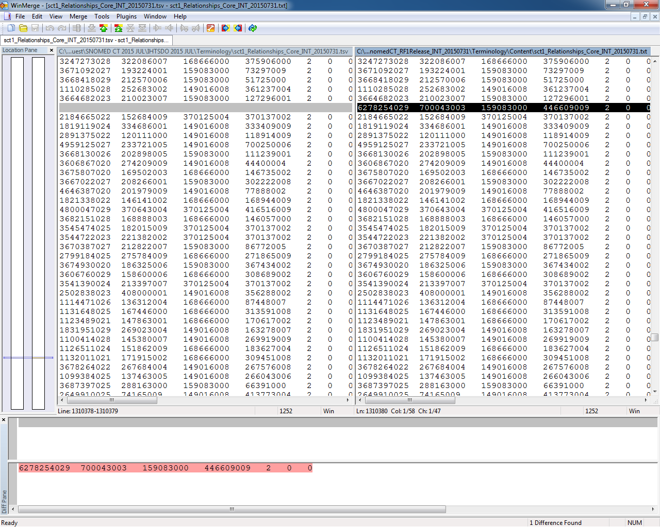
To find out more details for this extra record:
RELATIONSHIPID | CONCEPTID1 | RELATIONSHIP  TYPE | CONCEPTID2 | CHARACTERISTIC  TYPE | REFINABILITY | RELATIONSHIP  GROUP
6278254029 | 700043003  FSN:  Example problem list concepts reference set (foundation metadata concept) | 159083000  WAS A (ATTRIBUTE) | 446609009  Cannot find the FSN at RF1 file | 2 | 0 | 0

